**Biology Paper 1 Exam Questions**

**Topics B1 – B4**

**Name ________________**

**Class _______________**

**Contents Page**

|  |  |  |  |
| --- | --- | --- | --- |
| **B1 – Cell Biology** | | | |
| **Topic** | **Booklet Pages** | **Revision Guide Pages** | **Exam Questions** |
| Cells, Specialised Cells and Microscopy (inc. RP) | 3-10 | 11 – 14 | 3-8 |
| Chromosomes, Cell Division and Stem Cells | 11-12 | 15 – 16 | 9-14 |
| Transporting Substances   * Diffusion * Osmosis (inc. RP) * Active Transport * Exchanging Substances | 13-19 | 17  18  19  21 – 22 | 15-23 |

|  |  |  |  |
| --- | --- | --- | --- |
| **B2 – Organisation** | | | |
| **Topic** | **Booklet Pages** | **Revision Guide Pages** | **Exam Questions** |
| Digestive System and Enzymes | 20-26 | 24 – 27 | 24-35 |
| Food Tests (Required Practical) | 27-28 | 28 | 36-39 |
| Breathing System | 29 | 29 | 40-43 |
| Circulatory System, Blood and Cardiovascular Disease | 30-37 | 30 – 34 | 44-55 |
| Non-Communicable Diseases | 38-40 | 35 – 37 | 56-62 |
| Plant Systems | 41-43 | 38 – 40 | 63-70 |

|  |  |  |  |
| --- | --- | --- | --- |
| **B3 – Infection and Response** | | | |
| **Topic** | **Booklet Pages** | **Revision Guide Pages** | **Exam Questions** |
| Communicable Diseases | 44-45 | 42 – 45 | 71-78 |
| Natural Defence Systems | 46-49 | 46 – 47 | 71-78 |
| Drugs | 50-52 | 48 – 49 | 79-83 |

|  |  |  |  |
| --- | --- | --- | --- |
| **B4 – Bioenergetics** | | | |
| **Topic** | **Booklet Pages** | **Revision Guide Pages** | **Exam Questions** |
| Photosynthesis (inc. RP) | 53-56 | 50 – 52 | 84-88 |
| Respiration and Exercise | 57-61 | 53 – 55 | 89-96 |

**B1 – Cells, Specialised Cells and Microscopes**

**Exam Question 1.**

The figure below shows four different types of cell.

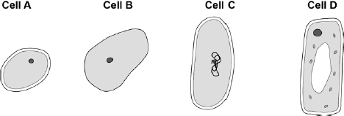

(a)     Which cell is a plant cell?

Give **one** reason for your answer.

Cell _________

Reason ____________________________________________________________

**(2)**

(b)     Which cell is an animal cell?

Give **one** reason for your answer.

Cell _________

Reason ____________________________________________________________

**(2)**

(c)     Which cell is a prokaryotic cell?

Give **one** reason for your answer.

Cell _________

Reason ____________________________________________________________

**(2)**

**(Total 6 marks)**

**Exam Question 2.**

This question is about cells.

(a)     (i)      The diagram shows a sperm cell.

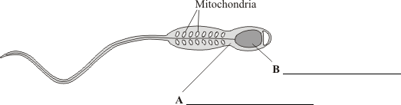

         Use words from the box to label parts **A** and **B**.

|  |
| --- |
| **cell membrane**         **cytoplasm**             **nucleus** |

**(2)**

(ii)     The diagram shows a cell from a leaf.

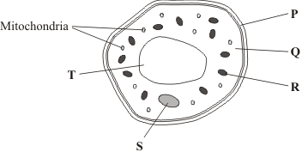

Give the letters of **two** parts of the leaf cell which would **not** be found in a sperm cell.

 and .

**(1)**

The diagrams show four types of cell, **A**, **B**, **C** and **D**.  
Two of the cells are plant cells and two are animal cells.

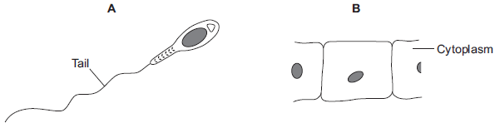

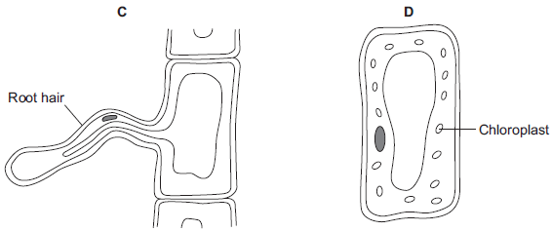

(a)     (i)      Which **two** of the cells are plant cells?

Tick () **one** box.

|  |  |
| --- | --- |
| **A** and **B** |  |
| **A** and **D** |  |
| **C** and **D** |  |

**(1)**

(ii)     Give **one** reason for your answer.

___________________________________________________________________

**(1)**

**(Total 3 marks)**

**Exam Question 3.**

(a)     This question is about comparing cells.

(ii)     Give **one** difference between the structure of the bacterial cell and an animal cell.

______________________________________________________________

**(1)**

(iii)    Name **one** structure that is found in a plant cell but is **not** found in a bacterial or an animal cell.

______________________________________________________________

**(1)**

(b)     Cells can be specialised for a particular job.

The diagram shows the structure of a human sperm cell.

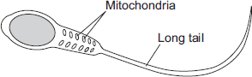

Describe how the long tail and the mitochondria help the sperm to do its job.

Long tail ___________________________________________________________

___________________________________________________________________

___________________________________________________________________

Mitochondria ________________________________________________________

___________________________________________________________________

___________________________________________________________________

**(4)**

**(Total 9 marks)**

**Exam Question 4.**

The image below shows some muscle cells from the wall of the stomach, as seen through a light microscope.

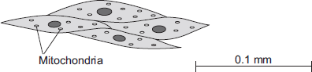

(a)     Describe the function of muscle cells in the wall of the stomach.

___________________________________________________________________

___________________________________________________________________

___________________________________________________________________

___________________________________________________________________

**(2)**

(b)     The figure above is highly magnified.

The scale bar in the figure above represents 0.1 mm.

Use a ruler to measure the length of the scale bar and then calculate the magnification of the figure above.

___________________________________________________________________

___________________________________________________________________

___________________________________________________________________

___________________________________________________________________

Magnification = _______________ times

**(2)**

(d)     The muscle cells also contain many ribosomes. The ribosomes cannot be seen in the figure above.

(i)      What is the function of a ribosome?

______________________________________________________________

______________________________________________________________

**(1)**

(ii)     Suggest why the ribosomes **cannot** be seen through a light microscope.

______________________________________________________________

______________________________________________________________

**(1)**

**(Total 6 marks)**

**Exam Question 5.**

**Figure 1** shows a cell viewed through a light microscope.

**Figure 1**

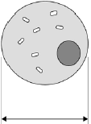

The size of the real cell is 0.03 mm.

(a)     Calculate the magnification of the microscope.

Use **Figure 1** to help you answer.

___________________________________________________________________

___________________________________________________________________

Magnification = ________________________

**(2)**

**(Total 2 marks)**

**B1 – Chromosomes, Stem Cells and Cell Division**

**Exam Question 1.**

The diagram shows how cells from human embryos can be used to grow ‘replacement body parts’ for humans.

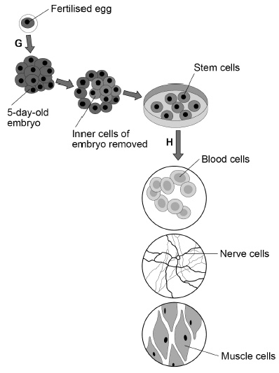

(a)     How many chromosomes are in a **fertilised** human egg?

Tick **one** box.

|  |  |  |  |  |  |  |  |
| --- | --- | --- | --- | --- | --- | --- | --- |
| 12 |  | 23 |  | 46 |  | 92 |  |

**(1)**

(b)     What is the process labelled **G**?

Tick **one** box.

|  |  |
| --- | --- |
| Fertilisation |  |
| Inheritance |  |
| Meiosis |  |
| Mitosis |  |

**(1)**

(c)     When the embryo is three days old, it contains eight cells.

How many times has the fertilised egg cell divided by day three?

Tick **one** box.

|  |  |  |  |  |  |  |  |
| --- | --- | --- | --- | --- | --- | --- | --- |
| 2 |  | 3 |  | 4 |  | 8 |  |

**(1)**

(d)     Stem cells become specialised in the process labelled **H** in the diagram.

What is the process labelled **H**?

Tick **one** box.

|  |  |
| --- | --- |
| Differentiation |  |
| Evolution |  |
| Genetic modification |  |
| Selective breeding |  |

**(1)**

(e)     Which **two** parts would be found in all the cells in the diagram.

Tick **two** boxes.

|  |  |
| --- | --- |
| Cell membrane |  |
| Cell wall |  |
| Chloroplasts |  |
| Cytoplasm |  |
| Plasmids |  |

**(2)**

(f)      Why might stem cells from human embryos be more useful than stem cells from adults?

___________________________________________________________________

___________________________________________________________________

**(1)**

(g)     Some parents have stem cells from the umbilical cord of their baby collected and stored.

These stem cells can be used to treat diseases in the child later in life.

Why might stem cells from their own umbilical cord be used rather than stem cells from another embryo?

Tick **one** box.

|  |  |
| --- | --- |
| Less risk of rejection of umbilical cord stem cells. |  |
| Stem cells from another embryo can treat more diseases. |  |
| Umbilical cord stem cells are older. |  |

**(1)**

(h)     Some medical uses of stem cells are still experimental.

Why do some scientists have concerns about the use of stem cells?

___________________________________________________________________

___________________________________________________________________

**(1)**

(i)      Some people object to the use of embryonic stem cells because of religious beliefs.

Give **one** other ethical concern about the use of embryonic stem cells?

___________________________________________________________________

___________________________________________________________________

**(1)**

**(Total 10 marks)**

**Exam Question 2.**

The photograph shows some cells in the root of an onion plant.

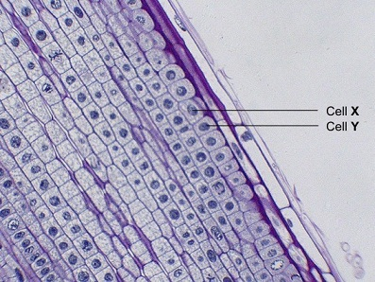

By UAF Center for Distance Education [CC BY 2.0], via Flickr

(a)      Cells **X** and **Y** have just been produced by cell division.

(i)      Name the type of cell division that produced cells **X** and **Y**.

______________________________________________________________

**(1)**

(ii)     What happens to the genetic material before the cell divides?

______________________________________________________________

**(1)**

(b)     A gardener wanted to produce a new variety of onion.

Explain why sexual reproduction could produce a new variety of onion.

___________________________________________________________________

___________________________________________________________________

___________________________________________________________________

___________________________________________________________________

___________________________________________________________________

___________________________________________________________________

**(3)**

**(Total 5 marks)**

**Exam Question 3.**

Stem cells can be collected from human embryos and from adult bone marrow.  
Stem cells can develop into different types of cell.

The table gives information about using these two types of stem cell to treat patients.

|  |  |
| --- | --- |
| **Stem cells from human embryos** | **Stem cells from adult bone marrow** |
| It costs £5000 to collect a few cells. | It costs £1000 to collect many cells. |
| There are ethical issues in using embryo stem cells. | Adults give permission for their own bone marrow to be collected. |
| The stem cells can develop into most other types of cell. | The stem cells can develop into only a few types of cell. |
| Each stem cell divides every 30 minutes. | Each stem cell divides every four hours. |
| There is a low chance of a patient’s immune system rejecting the cells. | There is a high chance of a patient’s immune system rejecting the cells. |
| More research is needed into the use of these stem cells. | Use of these stem cells is considered to be a safe procedure. |

Scientists are planning a new way of treating a disease, using stem cells.

Use **only** the information above to answer these questions.

(a)     Give **three** advantages of using stem cells from embryos instead of from adult bone marrow.

1. _________________________________________________________________

2. _________________________________________________________________

3. _________________________________________________________________

**(3)**

(b)     Give **three** advantages of using stem cells from adult bone marrow instead of from embryos.

1. _________________________________________________________________

2. _________________________________________________________________

3. _________________________________________________________________

**(3)**

**(Total 6 marks)**

**B1 – Transporting Substances (Diffusion, Osmosis, Active Transport)**

**Exam Question 1.**

(a)     The diagrams show cells containing and surrounded by oxygen molecules.  
Oxygen can move into cells or out of cells.

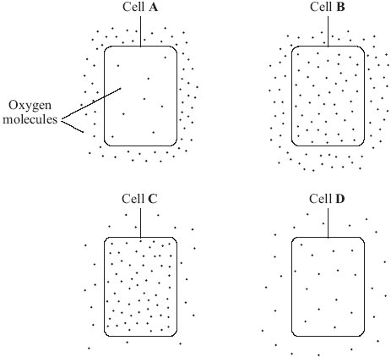

Into which cell, **A**, **B**, **C** or **D**, will oxygen move the fastest?

Write your answer, **A**, **B**, **C** or **D**, in the box.           

**(1)**

(b)     Draw a ring around the correct word to complete each sentence.

|  |  |  |
| --- | --- | --- |
| (i)       Oxygen is taken into cells by the process of | diffusion  osmosis  respiration | . |

**(1)**

|  |  |  |
| --- | --- | --- |
| (ii)      Cells need oxygen for | breathing  photosynthesis  respiration | . |

**(1)**

|  |  |  |
| --- | --- | --- |
| (iii)     The parts of cells that use up the most oxygen are the | membranes  mitochondria  nuclei | . |

**(1)**

|  |  |  |
| --- | --- | --- |
| (iv)     Some cells produce oxygen in the process of | diffusion  photosynthesis  respiration | . |

**(1)**

**(Total 5 marks)**

**Exam Question 2.**

**Figure 1** shows part of the lungs.

**Figure 1**

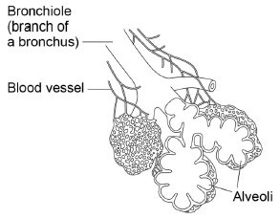

(a)     Give **two** ways the lungs are adapted for efficient exchange of gases.

Describe how each adaptation helps to maintain efficient gas exchange.

Adaptation 1 ________________________________________________________

___________________________________________________________________

Description _________________________________________________________

___________________________________________________________________

Adaptation 2 ________________________________________________________

___________________________________________________________________

Description _________________________________________________________

___________________________________________________________________

**(4)**

**(Total 4 marks)**

**Exam Question 3.**

Substances can move into cells and out of cells.

(a)     Draw a ring around the correct answer to complete each sentence.

|  |  |
| --- | --- |
|  | active transport. |
| Water moves into cells and out of cells by | osmosis. |
|  | reabsorption. |

|  |  |  |
| --- | --- | --- |
|  | freely permeable |  |
| The water moves through a | non-permeable | membrane. |
|  | partially permeable |  |

**(2)**

(b)     Students put plant cells into two different strengths of sugar solutions, **A** and **B**.

The diagram below shows what the cells looked like after 1 hour.

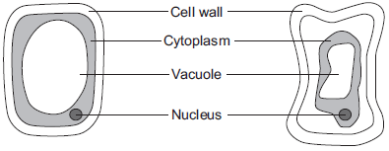

|  |  |  |
| --- | --- | --- |
| Cell in sugar solution **A** (after 1 hour) |  | Cell in sugar solution **B** (after 1 hour) |

(i)      Describe **two** ways in which the cell in sugar solution **B** is different from the cell in sugar solution **A**.

1. ____________________________________________________________

______________________________________________________________

2. ____________________________________________________________

______________________________________________________________

**(2)**

(ii)     A student put red blood cells into water.

Suggest what would happen to the cells.

______________________________________________________________

______________________________________________________________

______________________________________________________________

**(1)**

(c)     In the human body, glucose is absorbed into the blood from the small intestine.

The small intestine contains many villi.

Which **two** of the following help the absorption of glucose in the small intestine?

Tick () **two** boxes.

|  |  |
| --- | --- |
| Villi have a cell wall. |  |
| Villi are covered in thick mucus. |  |
| Villi give the small intestine a large surface area. |  |
| Villi have many blood capillaries. |  |

**(2)**

**(Total 7 marks)**

**Exam Question 4.**

Plant roots absorb water from the soil by osmosis.

(a)     What is osmosis?

___________________________________________________________________

___________________________________________________________________

___________________________________________________________________

___________________________________________________________________

___________________________________________________________________

___________________________________________________________________

**(3)**

(b)     The image below shows part of a plant root.

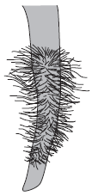

The plant root is adapted for absorbing water from the soil.

Use information from the diagram to explain how this plant root is adapted for absorbing water.

___________________________________________________________________

___________________________________________________________________

___________________________________________________________________

___________________________________________________________________

___________________________________________________________________

___________________________________________________________________

**(3)**

**(Total 6 marks)**

**Exam Question 5.**

The lugworm lives in a U-shaped burrow in the sand on the seashore.

The diagram below shows a lugworm in its burrow.

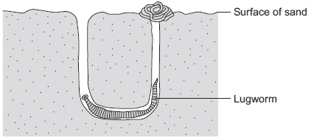

(a)     Some scientists investigated the effect of different salt concentrations on lugworms.

The scientists:

•        collected 50 lugworms from the seashore

•        separated them into five groups of 10 lugworms

•        weighed each group of 10 lugworms

•        placed each group into a different concentration of salt solution and left them for 8 hours

•        took each lugworm out of the solution and placed it on blotting paper for 30 seconds

•        re-weighed each group of 10 lugworms.

(i)      Why did the scientists use groups of 10 lugworms and not just 1 lugworm at each concentration?

______________________________________________________________

______________________________________________________________

**(1)**

(ii)     Suggest why the scientists placed each lugworm on blotting paper for 30 seconds before they reweighed the groups of lugworms.

______________________________________________________________

______________________________________________________________

**(1)**

(iii)    How might the method of blotting have caused errors in the results?

______________________________________________________________

______________________________________________________________

**(1)**

(iv)    Suggest **one** improvement the scientists could make to their investigation.

______________________________________________________________

**(1)**

(b)     The table below shows the scientists’ results.

|  |  |  |  |  |
| --- | --- | --- | --- | --- |
| **Concentration of salt in arbitrary units** | **Mass of 10 lugworms at start in grams** | **Mass of 10 lugworms after 8 hours in grams** | **Change in mass in grams** | **Percentage (%) change in mass** |
| 1.0 | 41.2 | 61.8 | +20.6 | +50 |
| 2.0 | 37.5 | 45.0 | +7.5 |  |
| 3.0 | 55.0 | 56.1 | +1.1 | +2 |
| 4.0 | 46.2 | 22.2 | -24.0 | -52 |
| 5.0 | 45.3 | 22.6 | -22.7 | -50 |

(i)      The scientists calculated the **percentage** change in mass at each salt concentration.

Why is the **percentage** change in mass more useful than just the change in mass in grams?

Use information from the table in your answer.

______________________________________________________________

______________________________________________________________

______________________________________________________________

______________________________________________________________

**(2)**

(ii)     Calculate the percentage change in mass for the 10 lugworms in the salt solution with a concentration of 2.0 arbitrary units.

______________________________________________________________

______________________________________________________________

Percentage change in mass = ______________________ %

**(2)**

(c)     (i)      On the graph paper below, draw a graph to show the scientists’ results:

•        plot the **percentage** change in mass

•        label the horizontal axis

•        draw a line of best fit.

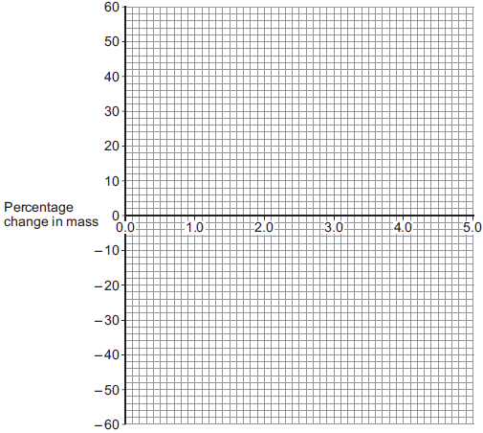

**(4)**

(ii)     The scientists thought one of their results was anomalous.

Draw a ring around the anomalous result on your graph.

**(1)**

(iii)    Suggest what might have happened to cause this anomalous result.

______________________________________________________________

______________________________________________________________

**(1)**

(d)     (i)      What do you think is the concentration of salts in the lugworm’s natural environment?

Use information from your graph to give the reason for your answer.

Concentration = ______________________ %

Reason _______________________________________________________

______________________________________________________________

______________________________________________________________

______________________________________________________________

**(2)**

(ii)     The mass of the lugworms decreased in the salt solution with a concentration of 5.0 arbitrary units.

Explain what caused this.

______________________________________________________________

______________________________________________________________

______________________________________________________________

______________________________________________________________

______________________________________________________________

______________________________________________________________

**(3)**

**(Total 19 marks)**

**B2 – Digestion and Enzymes**

**Exam Question 1.**

The diagram below shows the parts of the body that digest and absorb food.

It also shows some details about the structure of the stomach.

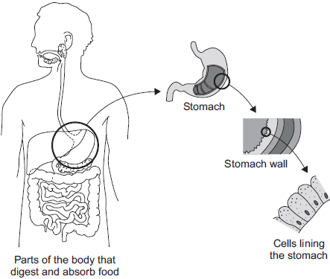

(a)     Complete the table to show whether each structure is an organ, an organ system or a tissue.

For each structure, tick () **one** box.

|  |  |  |  |
| --- | --- | --- | --- |
| **Structure** | **Organ** | **Organ system** | **Tissue** |
| Stomach |  |  |  |
| Cells lining the stomach |  |  |  |
| Mouth, oesophagus, stomach, liver, pancreas, small and large intestine |  |  |  |

**(2)**

(b)     (i)      The blood going to the stomach has a high concentration of oxygen.

The cells lining the stomach have a low concentration of oxygen.

Complete the following sentence.

Oxygen moves from the blood to the cells lining the stomach by

the process of ___________________________________ .

**(1)**

(ii)     What other substance must move from the blood to the cells lining the stomach so that respiration can take place?

Draw a ring around the correct answer.

|  |  |  |
| --- | --- | --- |
| **glucose** | **protein** | **starch** |

**(1)**

(iii)    In which part of a cell does aerobic respiration take place?

Draw a ring around the correct answer.

|  |  |  |
| --- | --- | --- |
| **cell membrane** | **mitochondria** | **nucleus** |

**(1)**

**(Total 5 marks)**

**Exam Question 2.**

**Figure 1** shows the human digestive system.

**Figure 1**

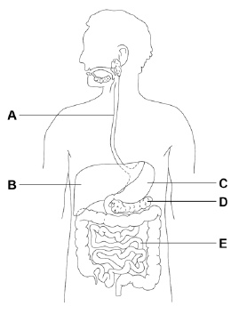

(a)     Which organ in **Figure 1** produces acid?

Tick **one** box.

|  |  |  |  |  |  |  |  |  |  |
| --- | --- | --- | --- | --- | --- | --- | --- | --- | --- |
| **A** |  | **B** |  | **C** |  | **D** |  | **E** |  |

**(1)**

(b)     Which organ in **Figure 1** produces bile?

Tick **one** box.

|  |  |  |  |  |  |  |  |  |  |
| --- | --- | --- | --- | --- | --- | --- | --- | --- | --- |
| **A** |  | **B** |  | **C** |  | **D** |  | **E** |  |

**(1)**

(c)     Where in **Figure 1** are digested foods absorbed into the blood?

Tick **one** box.

|  |  |  |  |  |  |  |  |  |  |
| --- | --- | --- | --- | --- | --- | --- | --- | --- | --- |
| **A** |  | **B** |  | **C** |  | **D** |  | **E** |  |

**(1)**

(d)     Food molecules such as proteins **cannot** be absorbed unless they are digested.

Give **one** reason why.

___________________________________________________________________

___________________________________________________________________

**(1)**

A scientist investigated the effect of pH on the activity of two protease enzymes.

**Figure 2** shows the results.

**Figure 2**

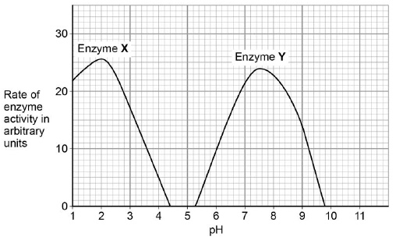

(e)     What is the optimum pH for enzyme **Y**?

pH ____________________

**(1)**

(f)      Where in the digestive system might the two protease enzymes be produced?

Tick **one** box.

|  |  |  |
| --- | --- | --- |
| **Enzyme X** | **Enzyme Y** |  |
| Mouth | Stomach |  |
| Pancreas | Mouth |  |
| Small intestine | Pancreas |  |
| Stomach | Small intestine |  |

**(1)**

**Figure 3** shows a model of an enzyme molecule.

**Figure 3**

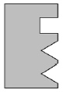

(g)     Which substrate fits the enzyme molecule in **Figure 3**?

Tick **one** box.

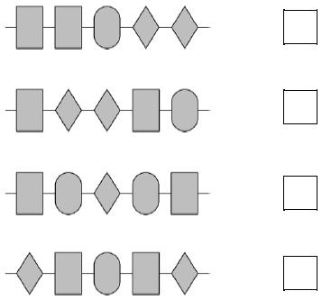

**(1)**

(h)     The enzyme and substrate diagrams are used as a model for a theory of enzyme action.

What is the name of this theory?

Tick **one** box.

|  |  |
| --- | --- |
| Evolution |  |
| Lock and key |  |
| Natural selection |  |
| Protein synthesis |  |

**(1)**

(i)      Explain why pH affects enzyme activity.

___________________________________________________________________

___________________________________________________________________

___________________________________________________________________

___________________________________________________________________

**(2)**

**(Total 10 marks)**

**Exam Question 3**

The diagram below shows the human digestive system.

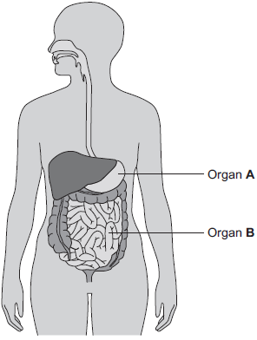

(a)     (i)      What is Organ **A**?

Draw a ring around the correct answer.

**gall bladder                liver                stomach**

**(1)**

(ii)     What is Organ **B**?

Draw a ring around the correct answer.

**large intestine                pancreas                small intestine**

**(1)**

(b)     Digestive enzymes are made by different organs in the digestive system.

Complete the table below putting a tick (✓) or cross (✕) in the boxes.

The first row has been done for you.

|  |  |  |  |  |  |
| --- | --- | --- | --- | --- | --- |
|  | | **Organ producing enzyme** | | | |
|  | | **salivary glands** | **stomach** | **pancreas** | **small intestine** |
| **Enzyme** | **amylase** | ✓ | ✕ | ✓ | ✓ |
| **lipase** |  |  |  |  |
| **protease** |  |  |  |  |

**(2)**

(c)     The stomach also makes hydrochloric acid.

How does the acid help digestion?

___________________________________________________________________

___________________________________________________________________

**(1)**

(d)     Draw **one** line from each digestive enzyme to the correct breakdown product.

|  |  |  |
| --- | --- | --- |
| **Digestive enzyme** |  | **Breakdown products** |
|  |  |  |
|  |  | **amino acids.** |
| **Amylase breaks down starch into……** |  |  |
|  |  | **bases.** |
| **Lipase breaks down fats into…** |  |  |
|  |  | **fatty acids and glycerol.** |
| **Protease breaks down proteins into…** |  |  |
|  |  | **sugars.** |

**(3)**

**(Total 8 marks)**

**Exam Question 4.**

Proteins are broken down by protease enzymes.

(a)     Which organs in the digestive system produce protease enzymes?

Tick **one** box.

|  |  |
| --- | --- |
| Mouth and liver |  |
| Mouth and stomach |  |
| Pancreas and liver |  |
| Stomach and pancreas |  |

**(1)**

A student used a colorimeter to investigate the rate of protein digestion of an insoluble protein.

A colorimeter measures the percentage of light that passes through a liquid.

The student measured the percentage of light passing through different concentrations of protein suspension.

The student used the results to produce a concentration curve.

The table shows the results.

|  |  |
| --- | --- |
| **Concentration of protein in g/dm3** | **Percentage of light passing through the suspension** |
| 0.0 | 100 |
| 0.5 | 93 |
| 2.0 | 75 |
| 10.0 | 38 |

(b)     Plot the data from the table on **Figure 1**.

Draw a line of best fit.

**Figure 1**

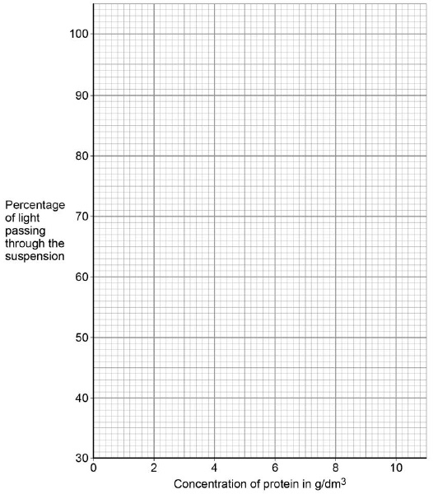

**(3)**

(c)     Explain the change in the percentage of light passing through the suspension.

___________________________________________________________________

___________________________________________________________________

___________________________________________________________________

___________________________________________________________________

**(2)**

(d)     Suggest how the student could improve their investigation to draw a more accurate concentration curve.

___________________________________________________________________

___________________________________________________________________

**(1)**

The student then investigated the rate of protein digestion with protease obtained from two different organs.

This is the method used.

1.     Put 5 cm3 of protease from each organ into separate test tubes.

2.     Put 10 cm3 of protein suspension into two other test tubes.

3.     Put all four tubes into a water bath at 37 °C for 10 minutes.

4.     Mix each 5 cm3 of protease into a tube of protein suspension.

5.     Take a sample of each mixture every 2 minutes.

6.     Measure the percentage of light passing through each sample using a colorimeter.

(e)     Suggest why the protease and the protein suspension were put into a water bath before being mixed.

___________________________________________________________________

___________________________________________________________________

**(1)**

**Figure 2** shows the student’s results.

**Figure 2**

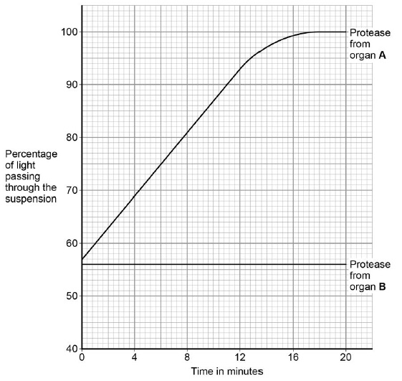

(f)      Determine the concentration of protein at the start of the reaction with protease from organ **A**.

Use **Figure 2** and your graph in **Figure 1**.

___________________________________________________________________

___________________________________________________________________

Concentration = ____________________ g/dm3

**(1)**

(g)     Calculate the rate of protein digestion with protease from organ **A** over the first 12 minutes.

Use **Figure 2** and your graph in **Figure 1**.

___________________________________________________________________

___________________________________________________________________

___________________________________________________________________

___________________________________________________________________

Rate = ____________________ g/dm3 per minute

**(1)**

(h)     Describe how the activity of protease from organ **B** is different from the activity of protease from organ **A**.

Suggest **one** reason for the difference.

___________________________________________________________________

___________________________________________________________________

___________________________________________________________________

___________________________________________________________________

**(2)**

**(Total 13 marks)**

**B2 – Food Tests**

**Exam Question 1.**

An athlete decides to try a new type of protein drink after he exercises.

(a)     The athlete tests the protein drink to check it contains protein.

Which solution is used to test for protein in the drink?

Tick **one** box.

|  |  |
| --- | --- |
| Benedict’s |  |
| Biuret |  |
| Iodine |  |
| Universal indicator |  |

**(1)**

(b)     What colour will the solution turn to if there is protein in the drink?

Tick **one** box.

|  |  |
| --- | --- |
| Blue-black |  |
| Purple |  |
| Red |  |
| Yellow |  |

**(1)**

**Figure 1** shows the proportion of different nutrients in the protein drink.

**Figure 1**

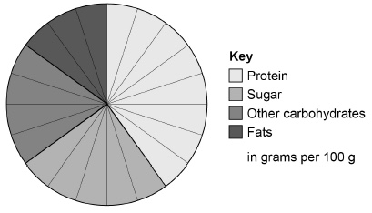

(c)     What is the ratio of sugar to protein in the protein drink?

|  |  |  |  |  |  |  |  |
| --- | --- | --- | --- | --- | --- | --- | --- |
| 1:1 |  | 1:0:6 |  | 1:2 |  | 1:1:6 |  |

**(1)**

(d)     Why is a high protein diet useful to an athlete?

Tick **one** box.

|  |  |
| --- | --- |
| Provides amino acids to make new muscle. |  |
| Provides fatty acids to produce urea. |  |
| Provides glucose for energy. |  |
| Provides lactic acid for anaerobic respiration. |  |

**(1)**

When the athlete drinks the protein drink the substances are digested.

The products of digestion are absorbed into the bloodstream.

Absorption happens in the small intestine.

**Figure 2** shows a section of the small intestine.

**Figure 2**

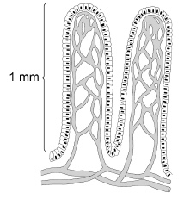

(e)     How is the small intestine in **Figure 2** adapted to absorb the products of digestion quickly?

Tick **two** boxes.

|  |  |
| --- | --- |
| It has a large surface area. |  |
| It has a long diffusion pathway. |  |
| It has a thin surface. |  |
| The concentration inside the small intestine is low. |  |
| It has a poor blood supply. |  |

**(2)**

(f)      **Figure 3** shows the proportion of different nutrients in four protein drinks.

**Figure 3**

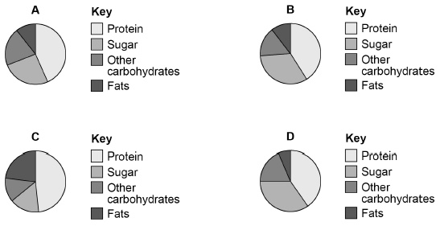

Which protein drink should an athlete with diabetes use?

Give a reason for your answer.

Drink ____________________

Reason ____________________________________________________________

___________________________________________________________________

**(2)**

**(Total 8 marks)**

**Exam Question 2**

Bread contains starch, protein and fat.

(a)     Complete each sentence by choosing the correct words from the box.

|  |  |
| --- | --- |
| **amino acids** | **protein** |
| **fat** | **starch** |
| **fatty acids** | **sugar** |

Amylase speeds up the digestion of _________________ . The product of this

digestion is _____________ . Protease speeds up the digestion of _____________ .

The product of this digestion is _______________________ .

**(4)**

(b)     Why do molecules of starch, protein and fat need to be digested?

______________________________________________________________

______________________________________________________________

**(2)**

(c)     In which part of the digestive system does the digestion of starch begin?  
Draw a ring around your answer.

**large intestine**       **mouth**              **small intestine**         **stomach**

**(1)**

(d)     What do we call substances like amylase and protease which speed up chemical reactions?

______________________________________________________________

**(1)**

**(Total 8 marks)**

**B2 – Breathing System**

**Exam Question 1.**

Our lungs help us to breathe.

The image below shows the human breathing system.

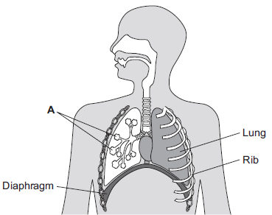

(a)     (i)      Name part **A**.

______________________________________________________________

**(1)**

(ii)     Give **one** function of the ribs.

______________________________________________________________

**(1)**

(b)     (i)      Use the correct answer from the box to complete the sentence.

|  |  |  |
| --- | --- | --- |
| **active transport** | **diffusion** | **osmosis** |

Oxygen moves from the air inside the lungs into the blood by the

process of __________________________ .

**(1)**

(ii)     Use the correct answer from the box to complete the sentence.

|  |  |  |
| --- | --- | --- |
| **arteries** | **capillaries** | **veins** |

Oxygen moves from the lungs into the blood through the walls

of the __________________________ .

**(1)**

(iii)    Inside the lungs, oxygen is absorbed from the air into the blood.

Give **two** adaptations of the lungs that help the rapid absorption of oxygen into the blood.

1. ____________________________________________________________

______________________________________________________________

2. ____________________________________________________________

______________________________________________________________

**(2)**

**(Total 6 marks)**

**Exam Question 2.**

The diagram shows an alveolus and a blood vessel in the lung.

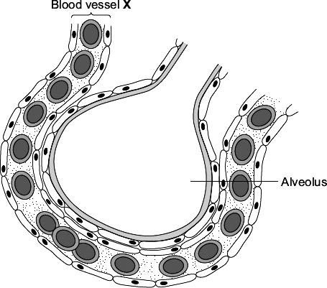

(a)     Draw a ring around the correct answer to complete each sentence.

|  |  |  |
| --- | --- | --- |
|  |  | an artery. |
| (i) | Blood vessel **X** is | a capillary. |
|  |  | a vein. |

**(1)**

|  |  |  |
| --- | --- | --- |
|  |  | diffusion. |
| (ii) | Gases pass across the wall of the alveolus by | evaporation. |
|  |  | fermentation. |

**(1)**

(iii)    The table compares the concentrations of some gases in inhaled air and exhaled air.

Complete the table.  
Write ‘lower’ **or** ‘higher’ in each box.  
One line has been completed for you as an example.

|  |  |  |
| --- | --- | --- |
| **Gas** | **Concentration** | |
| **Inhaled air** | **Exhaled air** |
| Water vapour | lower | higher |
| Carbon dioxide |  |  |
| Oxygen |  |  |

**(2)**

(b)     Draw a ring around the correct answer to complete each sentence.

|  |  |  |
| --- | --- | --- |
|  |  | blood plasma. |
| (i) | Oxygen is carried in the blood mainly in | red blood cells. |
|  |  | white blood cells. |

**(1)**

|  |  |  |
| --- | --- | --- |
|  |  | carbon dioxide. |
| (ii) | In the blood, the oxygen combines with | haemoglobin. |
|  |  | urea. |

**(1)**

**(Total 6 marks)**

**Exam Question 3.**

Gas exchange takes place in the lungs.

The diagram shows an alveolus next to a blood capillary in a lung.

The arrows show the movement of two gases, **A** and **B**.

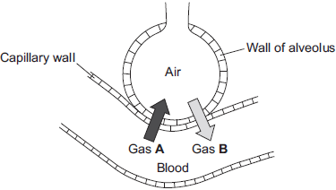

(a)     (i)      Draw a ring around the correct answer to complete the sentence.

|  |  |
| --- | --- |
| Gases **A** and **B** move by | diffusion.  osmosis.  respiration. |

**(1)**

(iii)    Which cells in the blood carry Gas **B**?

Draw a ring around the correct answer.

**platelets**                **red blood cells**                **white blood cells**

**(1)**

(b)     The average number of alveoli in each human lung is 280 million.

The average surface area of 1 million alveoli is 0.25 m2.

Calculate the total surface area of a human lung.

___________________________________________________________________

Answer ___________________________________ m2

**(2)**

(c)     An athlete trains to run a marathon. The surface area of each of the athlete’s lungs has increased to 80 m2.

Give **one** way in which this increase will help the athlete.

___________________________________________________________________

___________________________________________________________________

**(1)**

**(Total 6 marks)**

**B2 – Circulatory System**

**Exam Question 1.**

The heart is part of the circulatory system.

(a)     (i)      Name **one** substance transported by the blood in the circulatory system.

______________________________________________________________

**(1)**

(ii)     What is the main type of tissue in the heart wall?

______________________________________________________________

**(1)**

(b)     **Figure 1** shows the human heart.

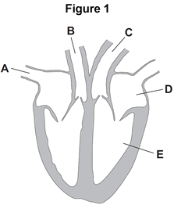

(i)      Which blood vessel, **A**, **B** or **C**, takes blood to the lungs?       

**(1)**

(ii)     Name parts **D** and **E** shown in **Figure 1**.

**D** _______________________________________

**E** _______________________________________

**(2)**

(c)     **Figure 2** shows three types of blood vessel, **F**, **G** and **H**.

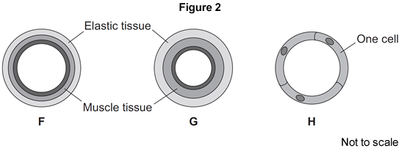

(i)      What type of blood vessel is **F?**

|  |  |
| --- | --- |
| Tick (✔) **one** box. |  |
| an artery |  |
| a capillary |  |
| a vein |  |

**(1)**

(ii)      A man needs to have a stent fitted to prevent a heart attack.

In which type of blood vessel would the stent be placed?

|  |  |
| --- | --- |
| Tick (✔) **one** box. |  |
| an artery |  |
| a capillary |  |
| a vein |  |

**(1)**

**(Total 7 marks)**

**Exam Question 2.**

**Figure 1** shows a diagram of the human heart.

**Figure 1**

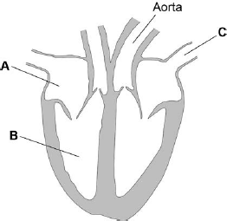

(a)     Name parts **A** and **B**.

**A** _________________________________________________________________

**B** _________________________________________________________________

**(2)**

(b)     What is the function of blood vessel **C**?

Tick **one** box.

|  |  |
| --- | --- |
| To take blood from the heart around the body |  |
| To take blood from the body to the heart |  |
| To take blood from the heart to the lungs |  |
| To take blood from the lungs to the heart |  |

**(1)**

(c)     Coronary heart disease (CHD) develops when layers of fatty material build up in the coronary artery.

One treatment for CHD is to insert a stent into the coronary artery.

**Figure 2** shows a stent in a coronary artery.

**Figure 2**

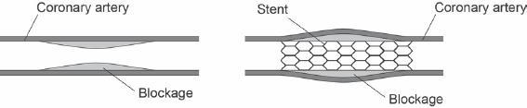

Explain why the stent helps to prevent a heart attack.

___________________________________________________________________

___________________________________________________________________

___________________________________________________________________

___________________________________________________________________

___________________________________________________________________

___________________________________________________________________

___________________________________________________________________

___________________________________________________________________

**(4)**

(d)     Look at the table below.

|  |  |  |
| --- | --- | --- |
| **Country** | **Number of deaths from CHD per 100 000 population per year** | **Amount of fruit and vegetables eaten in kg per person per year** |
| A | 285 | 180 |
| B | 250 | 320 |
| C | 198 | 250 |
| D | 151 | 220 |
| E | 125 | 244 |

Plot the missing bars for countries **D** and **E** on **Figure 3**.

Use data from the table above.

**Figure 3**

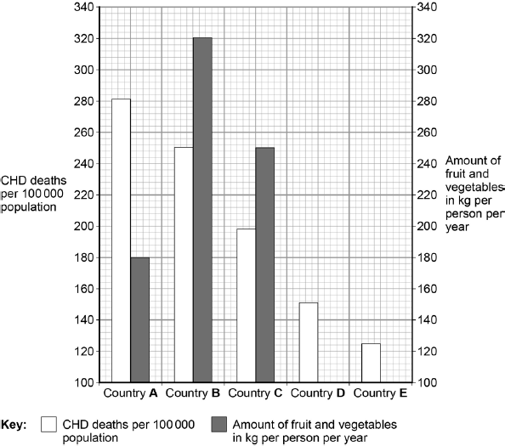

**(2)**

(e)     People in country **B** are more likely to die from CHD than people in country **E**.

How many more times as likely are people to die from CHD in country **B** than in country **E**?

___________________________________________________________________

**(1)**

(f)     A student concluded:

‘The factor that causes CHD is not eating enough fruit and vegetables.’

Evaluate the student’s conclusion.

Use data from **Figure 3**, and your own knowledge, in your answer.

___________________________________________________________________

___________________________________________________________________

___________________________________________________________________

___________________________________________________________________

___________________________________________________________________

___________________________________________________________________

___________________________________________________________________

___________________________________________________________________

___________________________________________________________________

___________________________________________________________________

**(6)**

**(Total 16 marks)**

**Exam Question 3.**

The circulatory system transports substances such as glucose and oxygen around the body.

(a)     Name **two** other substances that the circulatory system transports around the body.

1. _________________________________________________________________

2. _________________________________________________________________

**(2)**

(b)     (i)      Blood is a tissue. Blood contains red blood cells and white blood cells.

Name **two** other components of blood.

1. ____________________________________________________________

2. ____________________________________________________________

**(2)**

(ii)     The heart is part of the circulatory system.

What type of tissue is the wall of the heart made of?

______________________________________________________________

**(1)**

(c)     **In this question you will be assessed on using good English, organising information clearly and using specialist terms where appropriate.**

Every year, many patients need to have heart valve replacements.

The table gives information about two types of heart valve.

|  |  |
| --- | --- |
| **Living human heart valve** | **Cow tissue heart valve** |
| •   It has been used for transplants for     more than 12 years. | •   It has been used since 2011. |
| •   It can take many years to find a suitable     human donor. | •   It is made from the artery tissue of a     cow. |
| •   It is transplanted during an operation     after a donor has been found. | •   It is attached to a stent and inserted     inside the existing faulty valve. |
| •   During the operation, the patient's chest     is opened and the old valve is removed     before the new valve is transplanted. | •   A doctor inserts the stent into a blood     vessel in the leg and pushes it through     the blood vessel to the heart. |

A patient needs a heart valve replacement. A doctor recommends the use of a cow tissue heart valve.

Give the advantages and disadvantages of using a cow tissue heart valve compared with using a living human heart valve.

Use information from the table and your own knowledge in your answer.

___________________________________________________________________

___________________________________________________________________

___________________________________________________________________

___________________________________________________________________

___________________________________________________________________

___________________________________________________________________

___________________________________________________________________

___________________________________________________________________

___________________________________________________________________

___________________________________________________________________

**(6)**

**(Total 11 marks)**

**Exam Question 4.**

**Diagram 1** shows a section through the heart.

**Diagram 1**

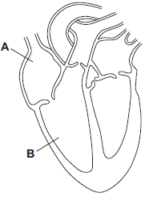

(a)     Use words from the box to name the structures labelled **A** and **B** on **Diagram 1**.

|  |  |  |  |
| --- | --- | --- | --- |
| **aorta** | **atrium** | **pulmonary artery** | **ventricle** |

**A** ___________________________________________________________

**B** ___________________________________________________________

**(2)**

(b)     The tissue in the wall of the heart contracts.

(i)      What type of tissue is this?

Tick () **one** box.

|  |  |
| --- | --- |
| muscular |  |
| glandular |  |
| epithelial |  |

**(1)**

(ii)     What does the heart do when this tissue contracts?

______________________________________________________________

______________________________________________________________

**(1)**

(c)     Draw arrows on **Diagram 2** to complete the route taken by deoxygenated blood through the heart.

**Diagram 2**

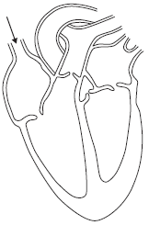

**(2)**

(d)     The graph shows the percentage (%) of adults in the UK who have coronary heart disease.

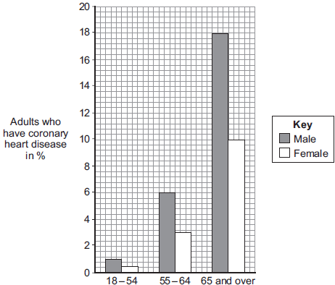  
Age group

(i)      Look at the graph.

Which group of people is **most** at risk of having coronary heart disease in the UK?

______________________________________________________________

**(2)**

(ii)     Explain what happens to the heart in coronary heart disease.

______________________________________________________________

______________________________________________________________

______________________________________________________________

______________________________________________________________

______________________________________________________________

______________________________________________________________

**(3)**

**(Total 11 marks)**

**Exam Question 5.**

**Diagram 1** shows a section through the heart.

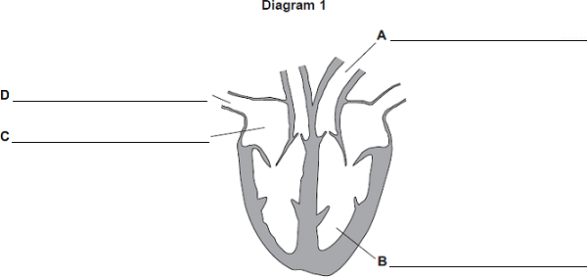

(a)     On the diagram, name the parts labelled **A**, **B**, **C** and **D**.

**(4)**

(b)     **Diagram 2** shows the blood vessels that supply the heart muscle.

Part of one of the blood vessels has become narrower.

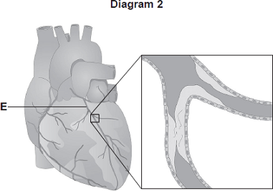

© Peter Gardiner/Science Photo Library

(i)      Name blood vessel **E**.

______________________________________________________________

**(1)**

(ii)     Give **one** method of treating the narrowed part of blood vessel **E**.

______________________________________________________________

**(1)**

(iii)    Explain how the method of treatment works.

______________________________________________________________

______________________________________________________________

______________________________________________________________

______________________________________________________________

**(2)**

(c)     **Diagram 3** shows part of the blood supply in the lungs.

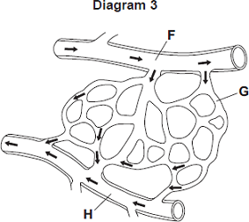

(i)      Name the types of blood vessel labelled **F**, **G** and **H**.

**F** ____________________________________________________________

**G** ____________________________________________________________

**H** ____________________________________________________________

**(3)**

(ii)     Give **one** way in which the composition of the blood in vessel **F** is different from the composition of the blood in vessel **H**.

______________________________________________________________

______________________________________________________________

**(1)**

**(Total 12 marks)**

**B2 – Non-Communicable Diseases**

**Exam Question 1.**

Scientists investigated the effect of different factors on health.

(a)     People who are **not** active may have health problems.

The graph shows the percentage of 16-year-olds in some countries who are **not** active.

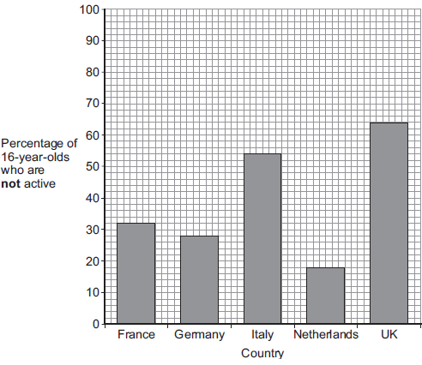

(i)      What percentage of 16-year-olds in the UK are **not** active?

_____________ %

**(1)**

(ii)     What percentage of 16-year-olds in the UK are **active**?

_____________ %

**(1)**

(iii)    A newspaper headline states:



Information in **Figure 1** does **not** support the newspaper headline.

Suggest **one** reason why the newspaper headline may be wrong.

______________________________________________________________

______________________________________________________________

**(1)**

(b)     Doctors gave a percentage rating to the health of 16-year-olds.  
100% is perfect health.

The table shows the amount of exercise 16-year-olds do and their health rating.

|  |  |
| --- | --- |
| **Amount of exercise done in minutes every week** | **Health rating as %** |
| Less than 30 | 72 |
| 90 | 76 |
| 180 | 82 |
| 300 | 92 |

What conclusion can be made about the effect of exercise on health?

Use information from the table.

___________________________________________________________________

___________________________________________________________________

**(1)**

(c)     Inherited factors can also affect health.

Give **one** health problem that may be affected by the genes someone inherits.

Draw a ring around the correct answer.

|  |  |  |
| --- | --- | --- |
| **being malnourished** | **having a high cholesterol level** | **having a deficiency disease** |

**(1)**

(d)     White blood cells are part of the immune system.

Use the correct answer from the box to complete each sentence.

|  |  |  |  |
| --- | --- | --- | --- |
| **antibiotics** | **antibodies** | **pathogens** | **vaccines** |

(i)      When we are ill, white blood cells produce _______________________ to kill microorganisms.

**(1)**

(ii)     Many strains of bacteria, including MRSA, have developed resistance to drugs called

______________________________________________________________

**(1)**

**(Total 7 marks)**

**Exam Question 2.**

When an organism grows, new cells are produced by cell division.

(a)     What type of cell division happens to produce new body cells?

Tick **one** box.

|  |  |
| --- | --- |
| Differentiation |  |
| Meiosis |  |
| Mitosis |  |

**(1)**

(b)     Why can cancers grow very large?

Tick **one** box.

|  |  |
| --- | --- |
| Cancer cells are specialised |  |
| Cell division is slow |  |
| Cell division is uncontrolled |  |

**(1)**

(c)     Give **one** factor which increases the risk of getting cancer.

___________________________________________________________________

**(1)**

(d)     Survival rates for people with cancer have improved a lot.

People who are alive 10 years after diagnosis are usually considered to be cured.

The figure below shows data for people diagnosed with cancer in 1961 and 2001.

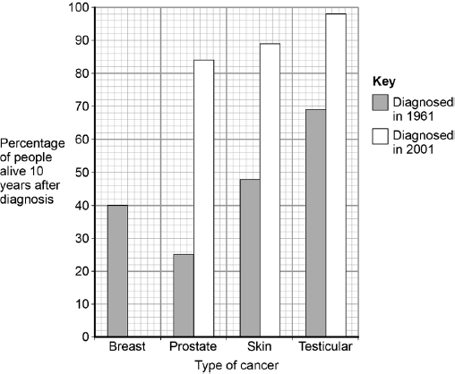

78% of people diagnosed with breast cancer in 2001 were alive 10 years later.

Complete the figure above to show this information.

**(1)**

(e)     Which type of cancer diagnosed in 1961 had the highest survival rate?

Tick **one** box.

|  |  |
| --- | --- |
| Breast |  |
| Prostate |  |
| Skin |  |
| Testicular |  |

**(1)**

(f)     Which type of cancer shows the biggest improvement in the percentage of people alive after 10 years?

Tick **one** box.

|  |  |
| --- | --- |
| Breast |  |
| Prostate |  |
| Skin |  |
| Testicular |  |

**(1)**

(g)     Suggest **two** reasons why the survival rates for all cancers have increased.

1. _________________________________________________________________

___________________________________________________________________

2. _________________________________________________________________

___________________________________________________________________

**(2)**

**(Total 8 marks)**

**Exam Question 3.**

The number of people in the UK with tumours is increasing.

(a)     (i)      Describe how tumours form.

______________________________________________________________

______________________________________________________________

**(1)**

(ii)     Tumours can be malignant or benign.

What is the difference between a malignant tumour and a benign tumour?

______________________________________________________________

______________________________________________________________

**(1)**

(b)     Describe how some tumours may spread to other parts of the body.

___________________________________________________________________

___________________________________________________________________

**(1)**

(c)     People from Northern Europe have fair skin and many people have malignant melanoma skin cancer.

The graph shows how the number of people in the UK with malignant melanoma changed between 1985 and 2008.

The bars on the graph show the number of people in the UK who travelled abroad and the number who took cheap holidays in the sun in 1985 and 2005.

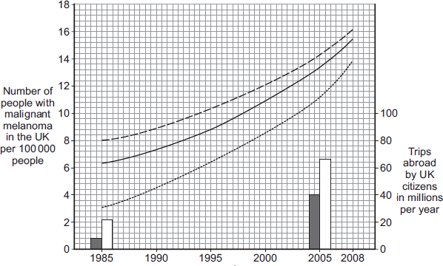  
Years

|  |  |
| --- | --- |
| **Key** | |
| Mean for all areas Mean for people from rich areas Mean for people from poor areas | Total number of trips abroad Number of cheap holidays in        the sun |

(i)      Describe the trends in the number of people with malignant melanoma skin cancer between 1985 and 2008.

______________________________________________________________

______________________________________________________________

______________________________________________________________

______________________________________________________________

______________________________________________________________

______________________________________________________________

**(3)**

(ii)     Use the data about the number of trips abroad to suggest an explanation for the trends you have described in part **(c)(i)**.

______________________________________________________________

______________________________________________________________

______________________________________________________________

______________________________________________________________

**(2)**

**(Total 8 marks)**

**B2 – Plant Systems**

**Exam Question 1.**

Substances are transported through plants.

(a)     Use the correct answer from the box to complete each sentence.

|  |  |  |
| --- | --- | --- |
| **capillary** | **guard cells** | **phloem** |
| **stomata** | **transpiration** | **xylem** |

(i)      Water is transported from the roots to the stem of a plant

in the ____________________________ .

**(1)**

(ii)     Dissolved sugars are transported through the plant

in the ____________________________ .

**(1)**

(iii)    Movement of water through the plant is called the

____________________________ stream.

**(1)**

(iv)    Water vapour moves out of the plant through pores

called ____________________________ .

**(1)**

(b)     Students investigated the effect of different conditions on water loss from leaves.

The apparatus is shown in **Figure 1**.

**Figure 1**

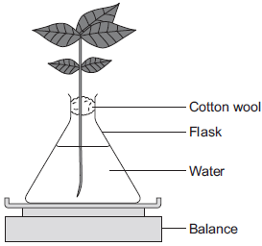

The students set up four flasks, **A**, **B**, **C** and **D**.

The students:

•        used the same size plant shoot in each flask

•        recorded the mass of the flask and plant shoot at the start of each experiment

•        left each flask and plant shoot in different conditions

•        recorded the mass of each flask and plant shoot after 2 hours.

**Table 1** shows the conditions that flasks **A**, **B**, **C** and **D** were left in for 2 hours.

**Table 1**

|  |  |  |
| --- | --- | --- |
| **Flask** | **Temperature in °C** | **Fan or no fan** |
| **A** | 20 | No Fan |
| **B** | 20 | Fan |
| **C** | 35 | No Fan |
| **D** | 35 | Fan |

(i)      Suggest why the students used cotton wool in each flask.

______________________________________________________________

______________________________________________________________

**(1)**

(ii)     The use of the same size of plant shoot made the investigation a fair test.

Explain why.

______________________________________________________________

______________________________________________________________

______________________________________________________________

______________________________________________________________

______________________________________________________________

**(2)**

(iii)    **Table 2** shows the students’ results.

**Table 2**

|  |  |  |  |  |  |
| --- | --- | --- | --- | --- | --- |
|  | **Conditions** | | **Mass at the start in grams** | **Mass after 2 hours in grams** | **Mass of water lost in 2 hours in grams** |
| **Flask** | **Temperature in °C** | **Fan or no fan** |
| **A** | 20 | No Fan | 150.0 | 148.1 | 1.9 |
| **B** | 20 | Fan | 152.0 | 148.5 | 3.5 |
| **C** | 35 | No Fan | 149.0 | 145.9 | 3.1 |
| **D** | 35 | Fan | 150.0 | 145.5 |  |

What mass of water was lost by the plant shoot in flask **D**?

______________________________________________________________

______________________________________________________________

___________ grams

**(1)**

(iv)    Suggest what conclusion can be made about the effect of temperature on water loss from the plant shoot.

______________________________________________________________

______________________________________________________________

______________________________________________________________

**(1)**

(v)     Suggest what conclusion can be made about the effect of the fan on water loss from the plant shoot.

______________________________________________________________

______________________________________________________________

______________________________________________________________

**(1)**

(c)     The students carried out another experiment at 20 °C, with no fan.

The students used the apparatus in **Figure 2**.

**Figure 2**

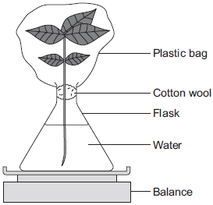

In this experiment, the students:

•        recorded the mass of the flask and plant shoot before tying the plastic bag around the plant shoot

•        removed the bag after 2 hours and recorded the mass again.

(i)      What mass of water would be lost from the plant shoot in 2 hours?

Draw a ring around the correct answer.

|  |  |  |
| --- | --- | --- |
| **0.3 g** | **1.9 g** | **3.9 g** |

**(1)**

(ii)     Give a reason for your answer to part **(c)(i)**.

______________________________________________________________

______________________________________________________________

______________________________________________________________

**(1)**

**(Total 12 marks)**

**Exam Question 2.**

The image below shows some cells on the lower surface of a leaf.

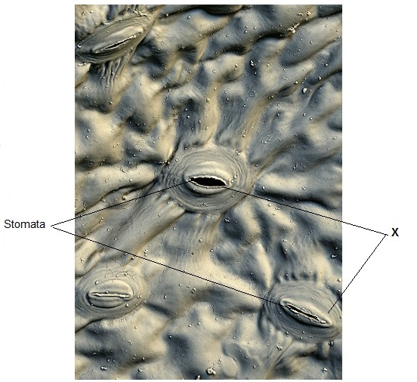

© Stefan Diller/Science Photo Library

(a)     What are the cells labelled **X** called?

Draw a ring around the correct answer.

**guard cells                palisade cells                mesophyll cells**

**(1)**

(b)     Water loss by evaporation from leaves is called **transpiration**.

A student set up an experiment to investigate water loss from leaves.

The student:

•        took two leaves, **A** and **B**, from a plant

•        put Vaseline (grease) on both sides of **Leaf B**; did nothing to **Leaf A**

•        wrote down the mass of each leaf

•        attached the leaves onto a string as shown in the diagram below.

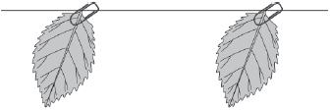

|  |  |
| --- | --- |
| **Leaf A** (no treatment) | **Leaf B** (both surfaces covered in Vaseline) |

•        left the leaves for 48 hours

•        wrote down the mass of each leaf again

•        calculated the percentage (%) change in mass for each leaf.

(i)      Give **one** variable that the student controlled in this investigation.

______________________________________________________________

______________________________________________________________

**(1)**

(ii)     The mass of **Leaf A** was 1.60 g at the start of the investigation. After 48 hours it was 1.28 g.

Calculate the % decrease in mass over 48 hours.

______________________________________________________________

______________________________________________________________

% decrease = __________________

**(2)**

(c)     Vaseline blocks the stomata.

The % change in mass of **Leaf B** was less than **Leaf A** after 48 hours.  
Explain why.

___________________________________________________________________

___________________________________________________________________

___________________________________________________________________

**(1)**

(d)     Give **three** environmental conditions that would increase transpiration.

1. _________________________________________________________________

2. _________________________________________________________________

3 _________________________________________________________________

**(3)**

**(Total 8 marks)**

**Exam Question 3.**

Plants transport many substances between their leaves and roots.

The diagram below shows the direction of movement of substances through a plant.

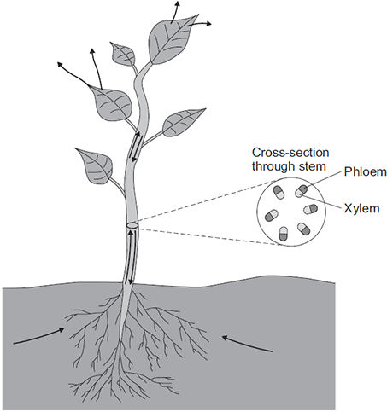

Describe how **ions**, **water** and **sugar** are obtained and transported through plants.

In your answer you should refer to materials moving upwards in a plant and to materials moving downwards in a plant.

_______________________________________________________________________

_______________________________________________________________________

_______________________________________________________________________

_______________________________________________________________________

_______________________________________________________________________

_______________________________________________________________________

_______________________________________________________________________

_______________________________________________________________________

_______________________________________________________________________

_______________________________________________________________________

_______________________________________________________________________

_______________________________________________________________________

_______________________________________________________________________

**(Total 6 marks)**

**B3 – Communicable Diseases and Defence Systems**

**Exam Question 1.**

Food poisoning can be caused by eating food that is contaminated with *Salmonella* bacteria.

(a)     Give **one** difference between a bacterial cell and an animal cell.

___________________________________________________________________

___________________________________________________________________

**(1)**

The table shows the number of confirmed cases of salmonella food poisoning in the UK.

|  |  |
| --- | --- |
| **Year** | **Confirmed cases per 100 000 population** |
| 2006 | 23.82 |
| 2007 | 22.24 |
| 2008 | 18.82 |
| 2009 | 17.17 |
| 2010 | 15.39 |
| 2011 | 15.12 |
| 2012 | 14.00 |
| 2013 | 13.16 |
| 2014 | 12.63 |
| 2015 | 14.50 |

It is estimated that in the UK, for every confirmed case of salmonella poisoning there are another 3 unconfirmed cases.

(b)     Estimate the total probability of suffering from salmonella food poisoning in 2015.

___________________________________________________________________

___________________________________________________________________

___________________________________________________________________

___________________________________________________________________

___________________________________________________________________

___________________________________________________________________

**(3)**

(c)     Describe the trend in the number of confirmed cases of salmonella food poisoning between 2006 and 2014.

___________________________________________________________________

___________________________________________________________________

**(1)**

(d)     Suggest two reasons for the trend in the data between 2006 and 2014.

1. _________________________________________________________________

___________________________________________________________________

2. _________________________________________________________________

___________________________________________________________________

**(2)**

(e)     The graph shows the number of confirmed cases of salmonella food poisoning in the UK during one year.

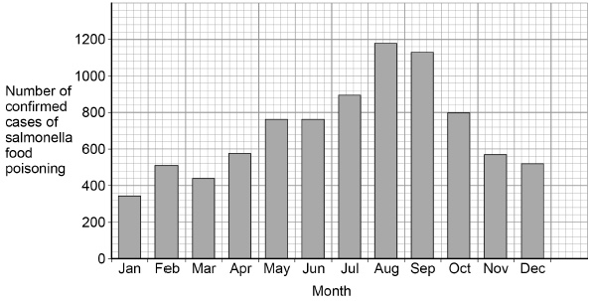

Suggest **one** reason for the high number of cases of salmonella food poisoning in the summer.

___________________________________________________________________

___________________________________________________________________

**(1)**

**(Total 8 marks)**

**Exam Question 2**

Some diseases are communicable.

(a)     What does communicable disease mean?

Tick **one** box.

|  |  |
| --- | --- |
| A disease that can be spread from one person to another. |  |
| A disease that cannot be treated with antibiotics. |  |
| A disease that is not spread from animals to humans. |  |
| A disease that is passed on through genes. |  |

**(1)**

(b)     A woman becomes ill and has the following symptoms:

•       pain when urinating

•       thick yellow discharge from vagina.

Which communicable disease does the woman have?

Tick **one** box.

|  |  |
| --- | --- |
| Gonorrhoea |  |
| HIV |  |
| Measles |  |
| Salmonella |  |

**(1)**

Tuberculosis is a bacterial infection that affects the lungs.

Tuberculosis causes severe discomfort.

(c)     What type of medicine should be used to kill the tuberculosis bacteria?

___________________________________________________________________

**(1)**

(d)     What type of medicine should be used to treat the symptoms of TB?

___________________________________________________________________

**(1)**

(e)     Describe the ways in which the human body defends itself against the tuberculosis bacterium.

___________________________________________________________________

___________________________________________________________________

___________________________________________________________________

___________________________________________________________________

___________________________________________________________________

___________________________________________________________________

___________________________________________________________________

___________________________________________________________________

**(4)**

**(Total 8 marks)**

**Exam Question 3**

Polio is a disease caused by a virus. In the UK, children are given polio vaccine to protect them against the disease.

(a)     In the sentences below, draw a ring around the correct words in each box.

(i)      It is difficult to kill the polio virus inside the body

|  |  |
| --- | --- |
| because the virus | is not affected by drugs  lives inside cells  produces antitoxins |

**(1)**

|  |  |  |
| --- | --- | --- |
| (ii)      The vaccine contains an | active  infective  inactive | form of the polio virus. |

**(1)**

(iii)     The vaccine stimulates the white blood cells to

|  |  |  |
| --- | --- | --- |
| produce | antibiotics  antibodies  drugs | which destroy the virus. |

**(1)**

(b)     The graph shows the number of cases of polio in the UK between 1948 and 1968.

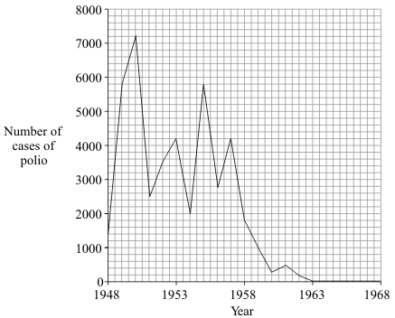

(i)      In which year was the number of cases of polio highest?

______________________________________________________________

**(1)**

(ii)     Polio vaccination was first used in the UK in 1955.

How many years did it take for the number of cases of polio to fall to zero?

______________________________________________________________

**(1)**

(iii)     There have been no cases of polio in the UK for many years. But children are still vaccinated against the disease.

Suggest **one** reason for this.

______________________________________________________________

______________________________________________________________

**(1)**

**(Total 6 marks)**

**Exam Question 4.**

Flu is an infectious disease caused by a virus. Many people in England become infected with the flu virus in winter.

(a)     Doctors do not prescribe antibiotics to patients with flu. Doctors do not prescribe antibiotics to patients with flu.

State why.

___________________________________________________________________

___________________________________________________________________

**(1)**

(b)     A flu vaccine is offered to people with a high risk of having a severe illness if they are infected by the flu virus.

What does a flu vaccine contain?

Tick () **one** box.

|  |  |
| --- | --- |
| Inactive antibodies |  |
| Inactive viruses |  |
| White blood cells |  |

**(1)**

(c)     The table shows the percentage of people in high-risk groups who had been vaccinated against flu by November in 2013. The data is for England.

|  |  |
| --- | --- |
| **Group at risk of a severe illness** | **Percentage (%) of group vaccinated by November in 2013** |
| 2-year-old children | 31.1 |
| 3-year-old children | 27.9 |
| People 65 years and older | 64.4 |

Give **one** conclusion from the data in the table above.

Suggest a reason for this.

Conclusion: _________________________________________________________

___________________________________________________________________

___________________________________________________________________

Reason: ____________________________________________________________

___________________________________________________________________

___________________________________________________________________

**(2)**

**Exam Question 5.**

Many diseases are caused by viruses. Children are given vaccines to protect them against viral disease.

(a)     Explain how vaccination protects a child against a viral disease.

___________________________________________________________________

___________________________________________________________________

___________________________________________________________________

___________________________________________________________________

___________________________________________________________________

___________________________________________________________________

**(3)**

(b)     In the 1990s many people thought that the MMR vaccine caused autism in some children. This is why the Japanese government stopped using the MMR vaccine.

The graph gives information about the percentage of Japanese children who developed autism during the 1990s.

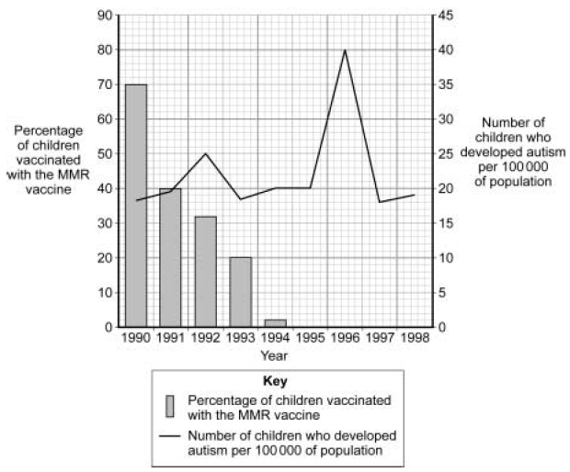

The data in the graph support the view that there is **no** link between MMR vaccination and autism.

Explain why.

___________________________________________________________________

___________________________________________________________________

___________________________________________________________________

___________________________________________________________________

___________________________________________________________________

___________________________________________________________________

___________________________________________________________________

___________________________________________________________________

___________________________________________________________________

**(4)**

**(Total 7 marks)**

**B3 – Drugs**

**Exam Question 1.**

New drugs have to be tested before they can be sold.

The graph shows how much time the different stages of testing took for a new drug.

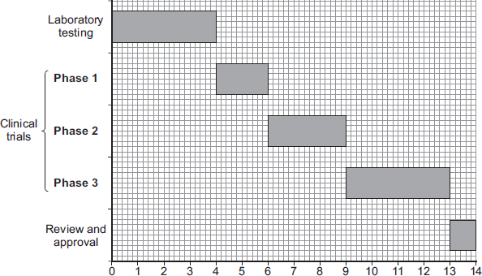  
                                    Time in years

(a)     (i)      How much time did the laboratory testing of the drug take?

____________________ years

**(1)**

(ii)     Suggest what the drug was tested on during laboratory testing.

______________________________________________________________

**(1)**

(b)     Clinical trials are carried out on human volunteers and patients.

(i)      How much time did the clinical trials take for this drug?

______________________________________________________________

____________________ years

**(2)**

(ii)     During **Phase 1** clinical trials, the drug is tested on healthy volunteers using low doses.

Draw a ring around the correct answer to complete the sentence.

|  |  |
| --- | --- |
|  | find the best dose. |
| The reason for **Phase 1** testing is to | see if the drug works. |
|  | see if the drug has side effects. |

**(1)**

(iii)    During **Phase 2** and **Phase 3** clinical trials, half of the volunteers are given a fake drug called a placebo in a double blind trial.

In a double blind trial, who knows which volunteers are given the drug and which volunteers are given the placebo?

Tick ( ) **one** box.

|  |  |
| --- | --- |
|  | **Tick ( )** |
| The doctors but not the volunteers |  |
| The doctors and the volunteers |  |
| The volunteers but not the doctors |  |
| Neither the volunteers nor the doctors |  |

**(1)**

**(Total 6 marks)**

**Exam Question 2**

New drugs have to be thoroughly tested before they are sold.

The diagram shows a time line for the testing of a new drug.

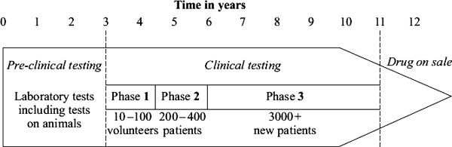

(a)    What is the main purpose of *pre-clinical testing?*

___________________________________________________________________

___________________________________________________________________

**(1)**

(b)     In Phase **1** of the *clinical testing,* very low doses of the new drug are used on a small number of volunteers.

(i)     What is the main purpose of Phase **1** testing?

______________________________________________________________

______________________________________________________________

**(1)**

(ii)     In Phase **1** testing, healthy volunteers are used rather than patients.

Suggest **one** reason for this.

______________________________________________________________

______________________________________________________________

**(1)**

(c)    What is the main purpose of the Phase **2** and Phase **3** testing?

___________________________________________________________________

___________________________________________________________________

**(1)**

(d)    During Phase **3** testing, many of the patients are given a *placebo.*

(i)     What is meant by a *placebo?*

______________________________________________________________

______________________________________________________________

**(1)**

(ii)     During the testing, who knows which patients are receiving the *placebo?*

Tick () **one** box.

|  |  |
| --- | --- |
| Only the patients |  |
| Only the doctors |  |
| Both patients and doctors |  |
| Neither patients nor doctors |  |

**(1)**

**(Total 6 marks)**

**Exam Question 4.**

In 2014 there was an outbreak of Ebola virus disease (EVD) in Africa.

At the time of the outbreak there were:

•        no drugs to treat the disease

•        no vaccines to prevent infection.

(a)     By March 2015 there were an estimated 9850 deaths worldwide from EVD.

The number of deaths is an estimate.

Suggest why it is an estimate rather than an exact number.

___________________________________________________________________

___________________________________________________________________

**(1)**

(b)     Why were no antibiotics used to treat EVD?

___________________________________________________________________

___________________________________________________________________

___________________________________________________________________

**(1)**

(c)     After the outbreak began, drug companies started to develop drugs and vaccines for EVD.

A drug has to be thoroughly tested and trialled before it is licensed for use.

Testing, trialling and licensing new drugs usually takes several years.

Draw **one** line from each word about drug testing to the definition of the word.

|  |  |  |  |  |
| --- | --- | --- | --- | --- |
| **Word about drug testing** | | |  | **Definition** |
|  |  |  |  |  |
|  | Dose |  |  | Side effects making the person ill |
|  |  |  |  |  |
|  | Efficacy |  |  | The concentration of the drug to be used and how often the drug should be given |
|  |  |  |  |  |
|  | Toxicity |  |  | Whether the drug works to treat the illness |

**(2)**

(d)     The results of drug testing and drug trials are studied in detail by other scientists.

Only then can the results be published by the drug company.

Suggest **one** reason why the results are studied by other scientists.

___________________________________________________________________

___________________________________________________________________

**(1)**

**(Total 5 marks)**

**B4 – Photosynthesis**

**Exam Question 1.**

Photosynthesis uses carbon dioxide to make glucose.

(a)     (i)      Complete the equation for photosynthesis.

carbon dioxide + _____________ glucose + _____________

**(2)**

(ii)     What type of energy does a plant use in photosynthesis?

______________________________________________________________

**(1)**

(iii)    Which part of a plant cell absorbs the energy needed for photosynthesis?

______________________________________________________________

**(1)**

(b)     The graph shows the effect of the concentration of carbon dioxide on the rate of photosynthesis in tomato plants at 20 °C.

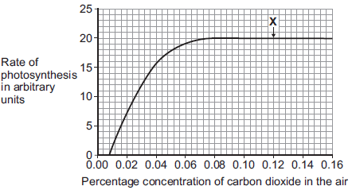

(i)      What is the maximum rate of photosynthesis of the tomato plants shown in the graph?

_____________ arbitrary units

**(1)**

(ii)     At point **X**, carbon dioxide is **not** a limiting factor of photosynthesis.

Suggest **one** factor that is limiting the rate of photosynthesis at point **X**.

______________________________________________________________

**(1)**

(c)     A farmer plans to grow tomatoes in a large greenhouse.

The concentration of carbon dioxide in the atmosphere is 0.04%.  
The farmer adds carbon dioxide to the greenhouse so that its concentration is 0.08%.

(i)      Why does the farmer use 0.08% carbon dioxide?

Tick () **one** box.

|  |  |
| --- | --- |
| To increase the rate of growth of the tomato plants |  |
| To increase the rate of respiration of the tomato plants |  |
| To increase water uptake by the tomato plants |  |

**(1)**

(ii)    Why does the farmer **not** use a concentration of carbon dioxide higher than 0.08%?

Tick () **two** boxes.

|  |  |
| --- | --- |
| Because it would cost more money than using 0.08% |  |
| Because it would decrease the temperature of the greenhouse |  |
| Because it would not increase the rate of photosynthesis of the tomato plants any further |  |
| Because it would increase water loss from the tomato plants |  |

**(2)**

**(Total 9 marks)**

**Exam Question 2.**

Students investigated the effect of light intensity on the rate of photosynthesis in pondweed.

The diagram shows the equipment the students used.

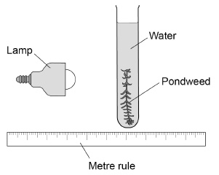

This is the method used.

1.        Place the lamp 50 cm from the pondweed.

2.        Count the number of bubbles of gas released in two minutes.

3.        Repeat steps 1–2 with the lamp at different distances from the pondweed.

(a)     The students could not make a firm conclusion because their method did not control enough variables.

Give **two** variables the students have **not** controlled that would affect the rate of photosynthesis.

1. _________________________________________________________________

2. _________________________________________________________________

**(2)**

The table shows the students’ results.

|  |  |  |  |  |  |
| --- | --- | --- | --- | --- | --- |
| **Distance of lamp from the pondweed in cm** | **Number of bubbles released in two minutes** | | | | |
| **1** | **2** | **3** | **4** | **Mean** |
| 50 | 5 | 8 | 6 | 5 | 6 |
| 40 | 10 | 8 | 9 | 4 | 9 |
| 30 | 12 | 12 | 15 | 17 | 14 |
| 20 | 25 | 17 | 23 | 24 | 24 |
| 10 | 22 | 34 | 31 | 31 | **X** |

(b)     Calculate the mean rate of bubbles produced per minute when the lamp was 10 cm from the pondweed.

___________________________________________________________________

___________________________________________________________________

Mean rate = ____________________ bubbles per minute

**(3)**

(c)     The mean number of bubbles released when the lamp was 30 cm away from the plant was greater than when the lamp was 50 cm away.

How many times greater?

___________________________________________________________________

Number of times greater = ____________________

**(1)**

(d)     The students wanted to find out if different wavelengths of light affect the number of bubbles released.

Describe how the method could be adapted to find the effect of different wavelengths of light.

___________________________________________________________________

___________________________________________________________________

___________________________________________________________________

___________________________________________________________________

**(2)**

**(Total 8 marks)**

**Exam Question 3**

Photosynthesis needs light.

(a)     Complete the **balanced symbol** equation for photosynthesis.

light

6CO2 + _______________________  _______________________ + 6O2

**(2)**

(b)     A green chemical indicator shows changes in the concentration of carbon dioxide (CO2) in a solution.

The indicator solution is **green** when the concentration of CO2 is normal.

The indicator solution turns **yellow** when the concentration of CO2 is high.

The indicator solution turns **blue** when the concentration of CO2 is very low or when there is no CO2.

The indicator solution does not harm aquatic organisms.

Students investigated the balance of respiration and photosynthesis using an aquatic snail and some pondweed.

The students set up four tubes, **A**, **B**, **C** and **D**, as shown in the table below.

The colour change in each tube, after 24 hours in the light, is recorded.

|  |  |  |  |
| --- | --- | --- | --- |
| **Tube A** | **Tube B** | **Tube C** | **Tube D** |
|  |  |  |  |
| Indicator solution only | Indicator solution + pondweed | Indicator solution + snail | Indicator solution + pondweed + snail |
| Stays green | Turns blue | Turns yellow | Stays green |

(i)      What is the purpose of **Tube A**?

______________________________________________________________

______________________________________________________________

**(1)**

(ii)     Explain why the indicator solution in **Tube C** turns yellow.

______________________________________________________________

______________________________________________________________

______________________________________________________________

______________________________________________________________

**(2)**

(iii)    Predict the result for **Tube D** if it had been placed in the dark for 24 hours and **not** in the light.

Explain your prediction.

Prediction _____________________________________________________

______________________________________________________________

Explanation ____________________________________________________

______________________________________________________________

______________________________________________________________

**(3)**

**(Total 8 marks)**

**B4 – Respiration and Exercise**

**Exam Question 1.**

Respiration can happen aerobically or anaerobically.

Respiration transfers energy from glucose.

(a)     Draw **one** line from each type of respiration in human cells to the correct information.

|  |  |  |
| --- | --- | --- |
| **Type of respiration in human cells** |  | **Information** |
|  |  |  |
|  |  | Produces ethanol |
|  |  |  |
| Aerobic respiration |  | Uses oxygen |
|  |  |  |
| Anaerobic respiration |  | Uses carbon dioxide |
|  |  |  |
|  |  | Produces lactic acid |

**(2)**

(b)     The table below shows the amount of energy released by aerobic and anaerobic respiration.

|  |  |
| --- | --- |
|  | **Energy in kJ transferred from 1 g of glucose** |
| Aerobic respiration | 16.1 |
| Anaerobic respiration | 1.2 |

Suggest why human cells might respire anaerobically, even though only a small amount of energy is transferred.

___________________________________________________________________

___________________________________________________________________

**(1)**

(c)     Yeast is used in the brewing and baking industries.

Why is yeast used in these industries?

___________________________________________________________________

___________________________________________________________________

___________________________________________________________________

___________________________________________________________________

___________________________________________________________________

___________________________________________________________________

**(4)**

**(Total 7 marks)**

**Exam Question 2**

An athlete ran as fast as he could until he was exhausted.

(a)     **Figure 1** shows the concentrations of glucose and of lactic acid in the athlete’s blood at the start and at the end of the run.

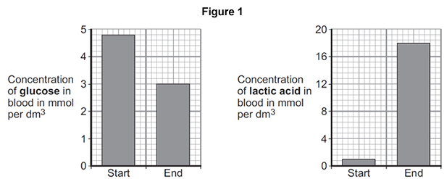

(i)      Lactic acid is made during anaerobic respiration.

What does anaerobic mean?

______________________________________________________________

______________________________________________________________

**(1)**

(ii)     Give evidence from **Figure 1** that the athlete respired anaerobically during the run.

______________________________________________________________

______________________________________________________________

**(1)**

(b)     **Figure 2** shows the effect of running on the rate of blood flow through the athlete’s muscles.

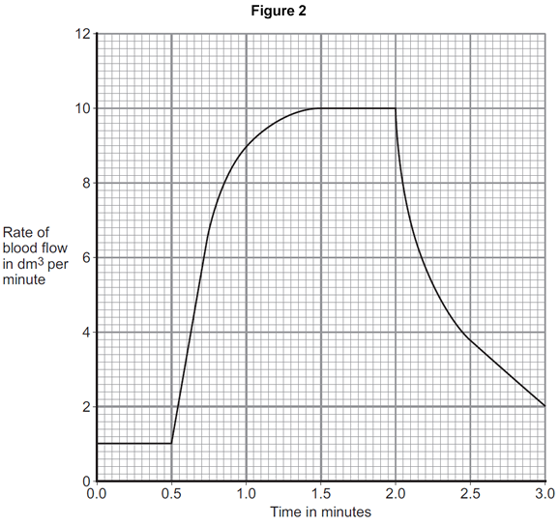

(i)      For how many minutes did the athlete run?

Time = ______________________ minutes

**(1)**

(ii)     Describe what happens to the rate of blood flow through the athlete’s muscles during the run.

Use data from **Figure 2** in your answer.

______________________________________________________________

______________________________________________________________

______________________________________________________________

______________________________________________________________

**(2)**

(iii)     Explain how the change in blood flow to the athlete’s muscles helps him to run.

______________________________________________________________

______________________________________________________________

______________________________________________________________

______________________________________________________________

______________________________________________________________

______________________________________________________________

______________________________________________________________

______________________________________________________________

______________________________________________________________

______________________________________________________________

**(4)**

**(Total 9 marks)**

**Exam Question 3.**

The mould *Penicillium* can be grown in a fermenter. *Penicillium* produces the antibiotic   
penicillin.

The graph shows changes that occurred in a fermenter during the production of   
penicillin.

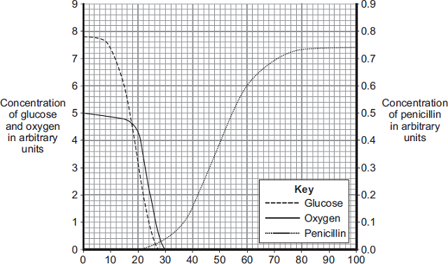

Time in hours

(a)     During which time period was penicillin produced most quickly?

Draw a ring around **one** answer.

|  |  |  |
| --- | --- | --- |
| **0 – 20 hours** | **40 – 60 hours** | **80 – 100 hours** |

**(1)**

(b)     (i)      Describe how the concentration of glucose in the fermenter changes between 0 and 30 hours.

______________________________________________________________

______________________________________________________________

______________________________________________________________

______________________________________________________________

**(2)**

(ii)     How does the change in the concentration of oxygen in the fermenter compare with the change in concentration of glucose between 0 and 30 hours?

Tick () **two** boxes.

|  |  |
| --- | --- |
| The oxygen concentration changes after the glucose concentration. |  |
| The oxygen concentration changes before the glucose concentration. |  |
| The oxygen concentration changes less than the glucose concentration. |  |
| The oxygen concentration changes more than the glucose concentration. |  |

**(2)**

(iii)    What is the name of the process that uses glucose?

Draw a ring around **one** answer.

|  |  |  |
| --- | --- | --- |
| **distillation** | **filtration** | **respiration** |

**(1)**

**(Total 6 marks)**

**Exam Question 4**

(a)     Use words from the box to complete the equation for aerobic respiration.

|  |  |  |  |
| --- | --- | --- | --- |
| **alcohol** | **glucose** | **lactic acid** | **water** |

______________ + oxygen   carbon dioxide + ______________ (+ energy)

**(2)**

(b)     Some students investigated the effect of temperature on the rate of aerobic respiration in earthworms.

The diagram shows the apparatus the students used.  
When the tap is closed, the bead of liquid moves to the left as the earthworms take in oxygen.

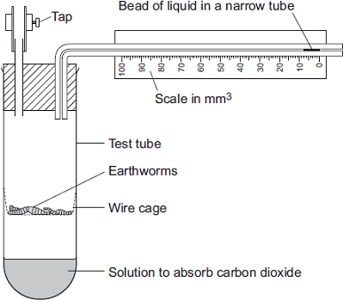

The students put the test tube into a water bath at 20°C for 10 minutes.  
They left the tap open during this time.

Why did the students put the test tube in the water bath at 20°C for 10 minutes?

Tick ( ) **one** box.

|  |  |
| --- | --- |
| Because the air contains more oxygen at 20°C. |  |
| Because the air contains less carbon dioxide at 20°C. |  |
| So the earthworms’ body temperature would change to 20°C. |  |

**(1)**

(c)     The students then:

•         closed the tap

•         started a stopwatch

•         recorded the position of the bead of liquid every 2 minutes for 10 minutes

•         repeated the experiment at 10°C.

The graph shows the students’ results.

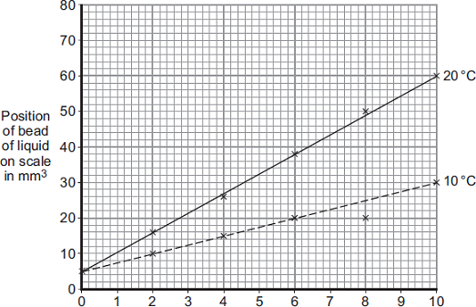

Time in minutes

(i)      How much oxygen did the earthworms take in during the 10 minutes at 20°C?

Use information from the graph to work out your answer.

______________________________________________________________

______________________________________________________________

Volume of oxygen taken in = ___________________ mm3

**(2)**

(ii)     The earthworms took in this volume of oxygen in 10 minutes.

Use your answer from part (c)(i) to calculate how much oxygen the earthworms took in each minute.

______________________________________________________________

______________________________________________________________

Volume of oxygen taken in = _______________________ mm3 per minute

**(1)**

(iii)    The earthworms took in less oxygen each minute at 10°C than they took in at 20°C.

Explain why.

______________________________________________________________

______________________________________________________________

______________________________________________________________

______________________________________________________________

**(2)**

(d)     When drawing the line on the graph for the experiment at 10°C, the students ignored the reading at 8 minutes.

(i)      Suggest why they ignored the reading at 8 minutes.

______________________________________________________________

______________________________________________________________

**(1)**

(ii)     One student suggested they should repeat the experiment twice more at each temperature.

How would repeating the experiment improve the investigation?

______________________________________________________________

______________________________________________________________

**(1)**

**(Total 10 marks)**